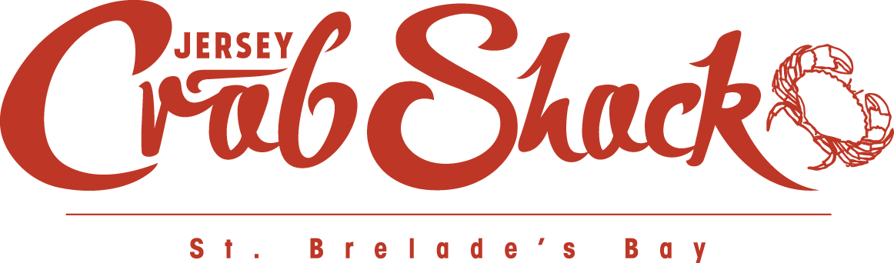

CONFIRMATION NUMBER: TABLE BOOKED FOR:  
1a2345b6 Wed, 4 Jan, 2017 at 6:00pm

Thank you for making a reservation at Jersey Crab Shack St. Brelade. Your table will be held for 15 minutes from the original booking time, so please do give us a call if you are running late.

|  |  |
| --- | --- |
| **Name** | Hayley Routier |
| **Restaurant** | Jersey Crab Shack St. Brelade [*Get directions*](https://www.google.co.in/maps?q=La+Route+de+la+BaieSt.+Brelade,+Jersey+JE3+8EF&ll=49.185557,-2.199771) |
| **Party of** | 4 |
| **Booking Notes** | [Notes] |

Link to: https://www.google.co.in/maps?q=La+Route+de+la+BaieSt.+Brelade,+Jersey+JE3+8EF&ll=49.185557,-2.199771

Our whole team look forward to welcoming you to Jersey Crab Shack St. Brelade. Please do not hesitate to contact us if you have any special requests or questions so we can ensure your visit is as enjoyable as possible. Menus and other information on Jersey Crab Shack and all other JPRestaurants locations are available online at [jprestaurants.com](http://jprestaurants.com/).

Should you wish to make any changes or cancel your booking, please use the link below or contact us on +441534850855 or via [stbrelade@jerseycrabshack.com](mailto:stbrelade@jerseycrabshack.com).  
  
Amend or cancel my booking

Link to http://jprestaurants.com/****Have you visited our other [JPRestaurants locations](http://jprestaurants.com/)?

**Please read the terms and conditions* outlined below carefully.**

**Your table will be available for two hours, after which it will be re-booked. Please contact us if you would like to stay at your table longer.** For tables booked at 14:00 or later, or 20:00 or later, your table will not be re-booked.

**Cancellations**A credit or debit card will be required to guarantee bookings of 8 or more people. We request at least four hours' notice for every cancellation. For bookings cancelled with less than four hours’ notice, we will charge £10.00 per person if we are unable to resell the table. In the event that you do not show up, we will charge £15.00 per person. [Read more](http://jprestaurants.com/booking-terms-conditions).  
Link to [http://jprestaurants.com/booking-terms-conditions](http://jprestaurants.com/?page_id=1699&preview=true)

**Table allocation**Due to the large number of requests, unfortunately we cannot guarantee window tables or specific areas when taking reservations, but we will do our best to accommodate your requests. Your understanding is appreciated. [Read more](http://oysterbox.co.uk/booking-terms-conditions/).  
Link to [http://jprestaurants.com/booking-terms-conditions](http://jprestaurants.com/?page_id=1699&preview=true)

**Food Safety**  
We respectfully ask that food that has not been prepared in our kitchens is not consumed on our premises. For the avoidance of doubt, this includes celebratory cakes so please ask if you would like a cake made. We cater for most dietary requirements and have strict policies in place for customers with food allergies. These policies and our allergen menus are available to view online at [jprestaurants.com](http://jprestaurants.com/news/eating-food-allergy).  
Link to <http://jprestaurants.com/news/eating-food-allergy>

*Detailed terms and conditions are available to [view online](http://jprestaurants.com/booking-terms-conditions).  
Link to [http://jprestaurants.com/booking-terms-conditions](http://jprestaurants.com/?page_id=1699&preview=true)

****Jersey Crab Shack St. Brelade  
St. Brelade’s Bay  
St. Brelade, Jersey, Channel Islands  
JE3 8EF  
Tel: +441534850855  
E-mail: [stbrelade@jerseycrabshack.com](mailto:stbrelade@jerseycrabshack.com)   
Website: [www.jerseycrabshack.com](http://www.jerseycrabshack.com)

Link to http://jprestaurants.com/